  VISUAL ANALYSIS  YouTube as a Classroom: Is Informal Learning the New Normal? | The following visuals have been included to complement and reinforce the synthesis essay. Each diagram supports a specific aspect of the comparison between Salaño’s and Lange’s perspectives on YouTube as a classroom.

Venn Diagram:

Formal vs. Informal Learning via YouTube (Salaño vs. Lange)

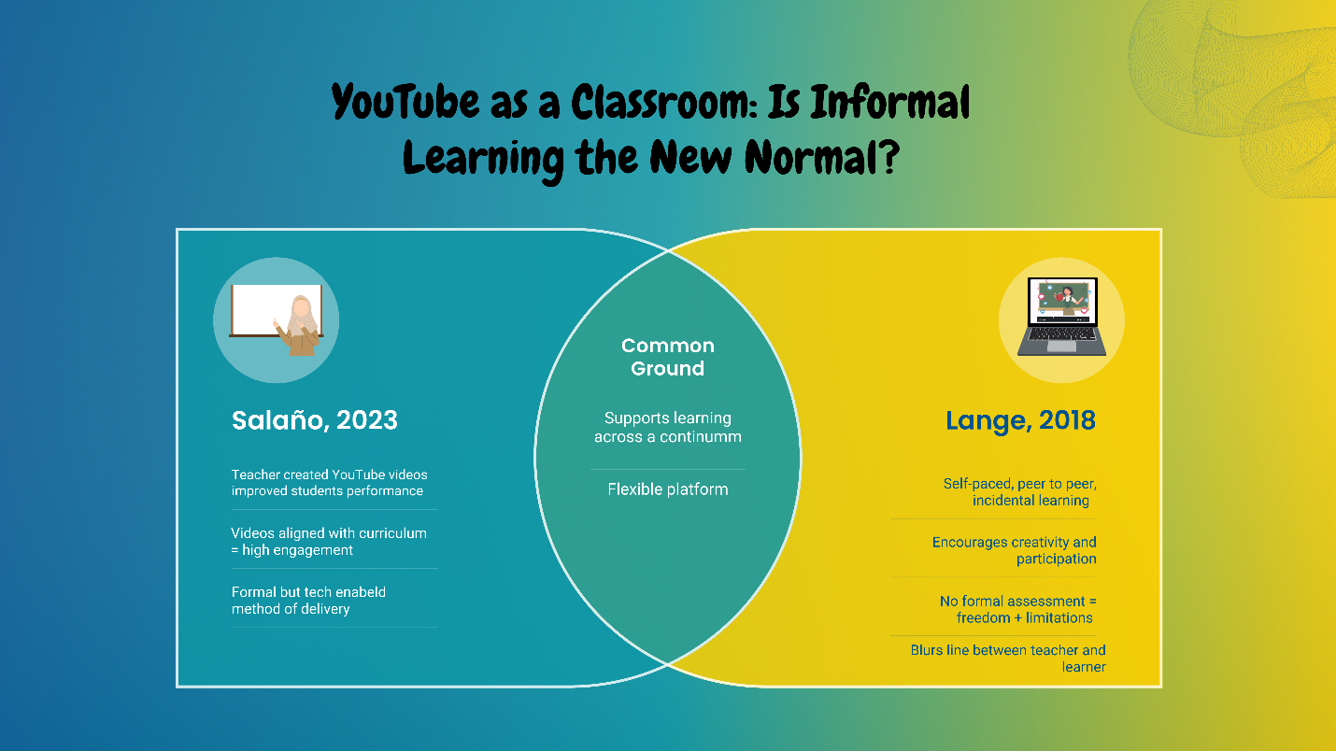

Caption:
This diagram clearly reflects the core synthesis of the essay. It shows how Salaño emphasizes structured, measurable learning through teacher-made videos, while Lange focuses on informal, peer-driven learning. The overlapping section represents the common ground—YouTube’s ability to educate across different styles. It visually supports the argument that both formal and informal learning coexist effectively on YouTube.

Comparative Table:
Comparison: Salaño (2023) vs. Lange (2018)

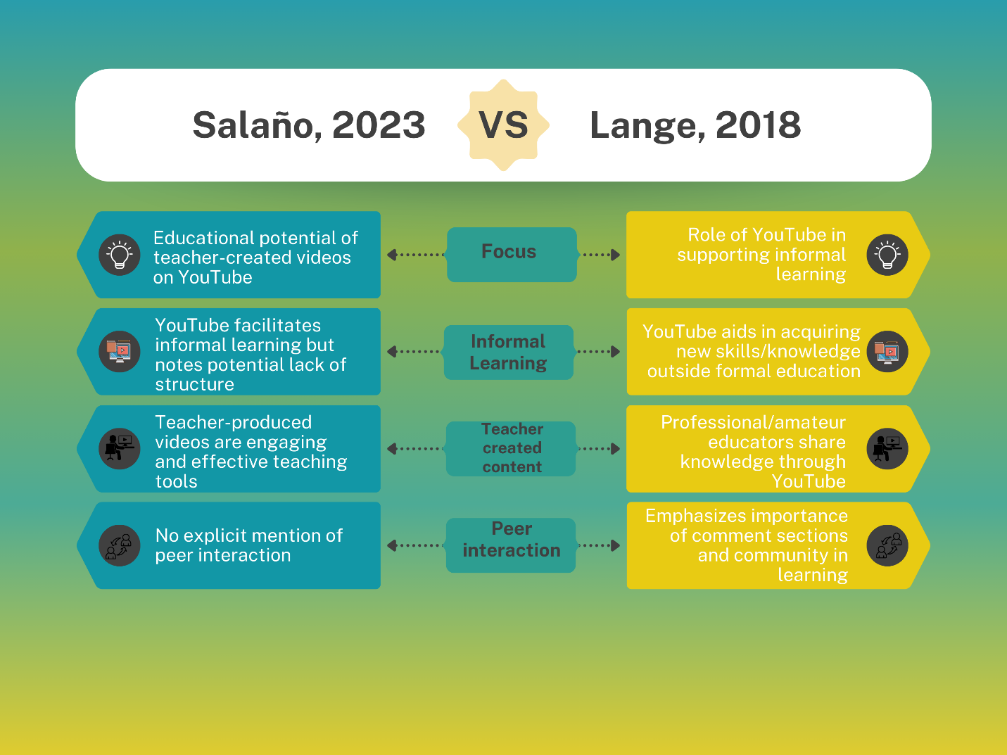

Caption:
The table gives a direct comparison between the two sources, breaking down their focus, methodology, and findings. Including it helps readers instantly grasp the contrasts in academic tone and educational approach, reinforcing the idea that YouTube can be interpreted in multiple valid ways—as a formal classroom tool or as a platform for informal learning.

Hybrid Learning Process Infographic:
Proposed Hybrid Learning Model

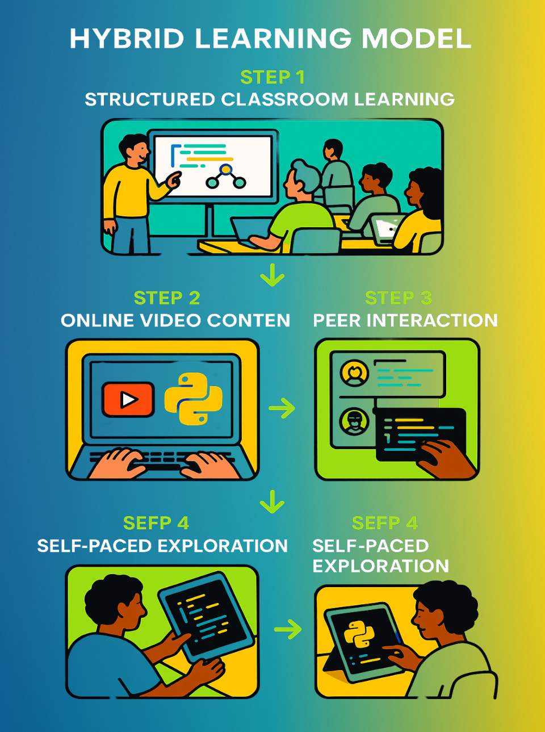

Caption:
This infographic represents the conclusion and stance of the essay—that hybrid learning models are the future. It maps the process of combining teacher-led YouTube videos with self-paced, informal exploration, illustrating how the strengths of both authors' views can be merged into a modern educational framework.
Concept Map:
YouTube's Educational Ecosystem

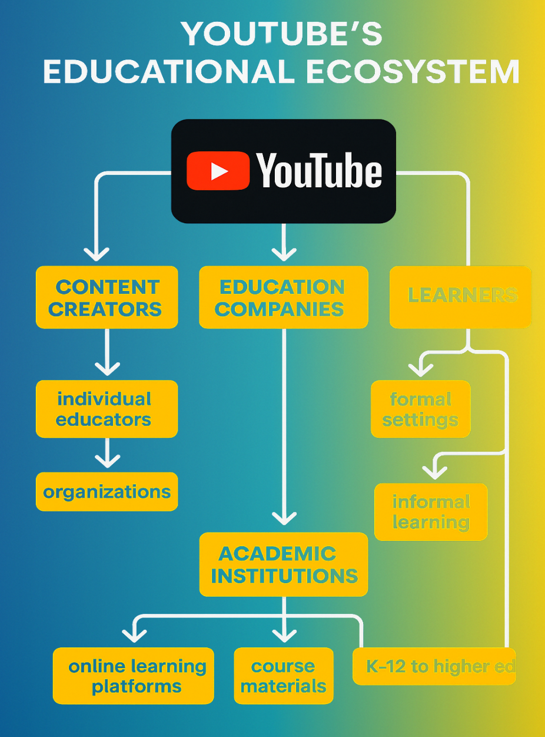

Caption:
This concept map expands the scope beyond the two texts, showing the broader ecosystem of learning on YouTube. It highlights connections between creators, institutions, learners, and the platform itself. It supports the essay’s message that YouTube is not just a video site, but a complex space that supports diverse forms of learning.
Thematic Infographic:
Key Elements of Digital Learning

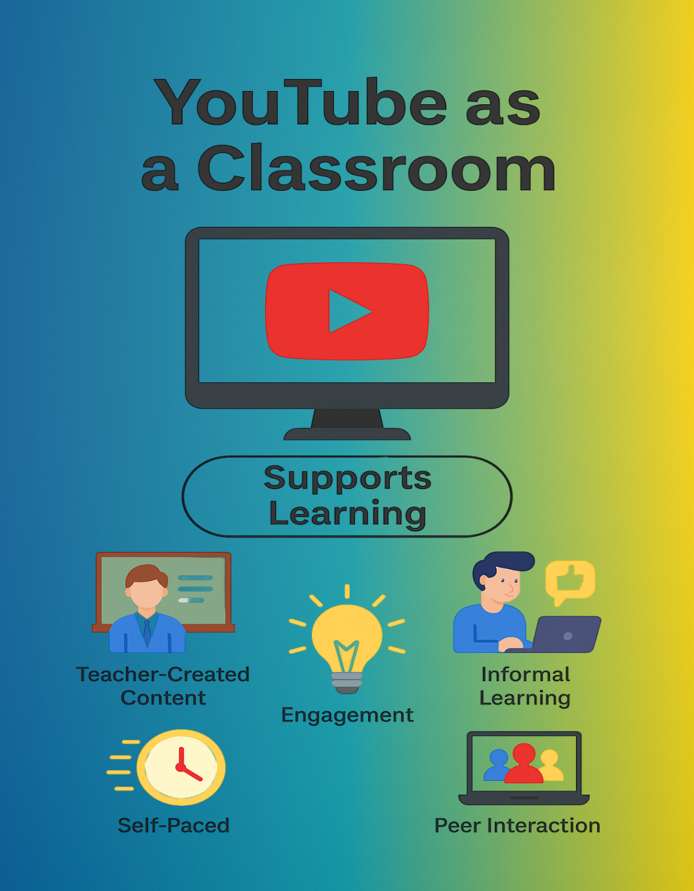

Caption:
This infographic summarizes the essential components of YouTube learning—such as accessibility, interactivity, and teacher-created content. It acts as a visual anchor for the essay’s theme and helps show why YouTube is increasingly seen as a legitimate and powerful learning space.

